Apple cellphones vs. Samsung cellphones: Methodology
Name
Institutional Affiliation

Apple cellphones vs. Samsung cellphones: Methodology

Introduction
The research method for the project report is used for the analysis of the information collected relevant to the identification and solution of any particular research problem concerning the brand loyalty of Apple Company and Samsung company .The objective behind this report was to sought a deep insight into the answers to research questions “What are the challenges experienced by cellphone scribers of Apple and Samsung companies and what they expect from the two cellphone providers as well as the research in the current cellphone market to find out why Apple mobile devices are more better compared to Samsung gadgets and Apple is more popular compared to Samsung company(West & Mace, 2010).
The essence of this project report is to analyze the current market position of Samsung and Apple cellphones among their rival companies as well as the challenges faced by retailers, wholesalers, and customers. The eventual research objectives are to suggest various recommendations to the two companies to assist them increase their global market share.

Research Problem1
Samsung and Apple Company has produced the best mobile technologies in the world for several decades. The study sought to found out why Apple cellphones tend to be the best devices among the mobile handset subscribers than Samsung cellphones as well as why the Apple mobile devices are more popular compared to Samsung .Moreover, Samsung phones has the best feature but it has been facing some safety issues for more than five decades.
The Study Objectives
The subject matter of this project report is to explore the consumer behavior towards Samsung and Apple mobile phones. The research consist of various objectives:
- To understand the level of consumer preference associated with Samsung and Apple cellphones
- To find the level of customer satisfaction towards Samsung and Apple
- To know why Apple cellphone more popular among the mobile subscribers than Samsung phones
Hypothesis
H₀: Apple mobile devices are more popular among the mobile handset subscribers than Samsung mobile gadgets
H_{a}: Apple mobile devices are not popular among the mobile handset subscribers than Samsung mobile gadgets
Plan of the Research
While designing the plan of the study one should take important decision concerning sampling technique, research instruments, research approach, and source of data etcetera.
- Sources of Data
There are two types of sources of data: Secondary and primary data. In my study I used both types of source data.
- Study Approach
Survey method: In the case of our study we used the survey method because it is an efficient strategy in studying the consumers’ satisfaction, preferences and knowledge concerning Samsung and Apple cellphones to measure these magnitudes in the market. While tours, and observation are best suited for various types of research such as exploratory type of study which is actually not the case of our research.
- Research instrument
In our study we used the Questionnaires to collect the information. Most of the questions were closed ended. The questionnaires were distributed to individuals to find out their level of satisfaction, quality, preferences, and demand.
- Sampling plan
After making a decision concerning the research instrument and approach, we designed a sampling plan .The sampling plan was constructed based on the following decisions:
Sampling unit: this involves defining what should surveyed or describing the target population which will be sampled .In our study various published journal in big towns and cities come under our sampling unit (Boulos et al.,2011)
Sampling size: the big sample size is important because it provides .In our research fifty (50) clients were surveyed in Chicago, in the United States.
Sampling procedure: area sampling technique was used in the case of our study since it is not possible visit all regions in the United States of America.

Data Collection
The data that was used for this study gathered by the use of questionnaires and interviews. The questionnaires constituted of both closed ended and open ended questions in order to encourage comprehensive and depth Reponses (Linden et al., 2009). Some questionnaires were filled by the respondents themselves (especially the literate customers), while the rest of the questionnaire were administered by the researcher with the help of the trained research assistants (for the case of semi- illiterate respondents).The questionnaires were administered to customers of both Samsung cellphones and Apple phones as well as the interviews were conducted on the customer care agents for both companies.
Research Ethical Considerations
The study was conducted according to the research ethical guidelines. The researcher provided a letter containing crucial and relevant information to the participants which included the information concerning the research .The researcher secured the full consent of the participants having them fill the consent form where they agreed to take part in the study voluntarily without undue inducement or threat.

Data Analysis, Interpretation and Conclusion
- Which the best mobile model between Apple and Samsung?

Response | Percentage
Samsung | 40%
Apple | 60%

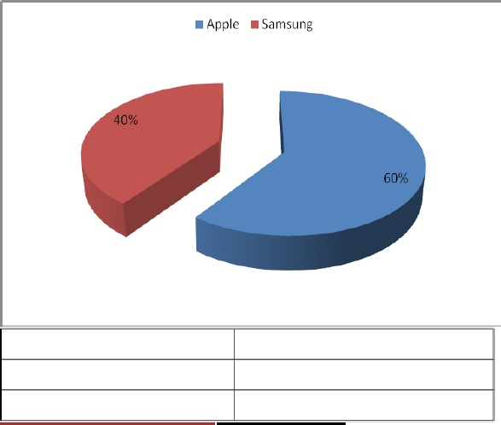

Out of hundred participants 40% prefers Samsung while 60% of the customers prefers Apple cellphone i-phone.
2. What are the reasons of preferring Samsung or Apple?
Response | Percentage
Price | 15%
Quality | 37%
Look | 12%
Feature | 36%
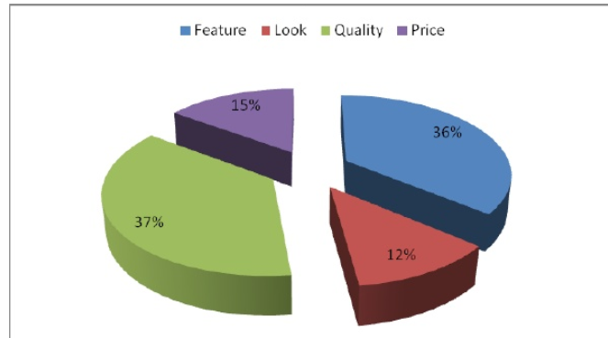
Out of 100 participants 15% prefer their phones because of the price, 12% because of the look, 36% due to features, and 37% because of the quality
3. Between Samsung and Apple phones, which model that has many features?
Response | Percentage
Samsung | 39%
Apple | 61%

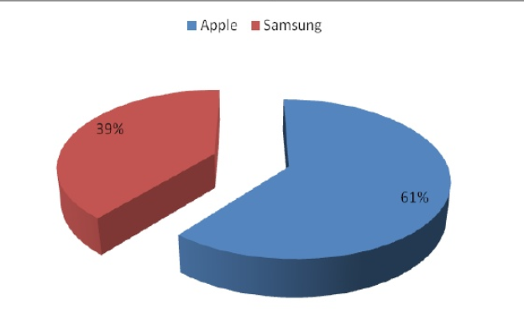
Out of 100 participants 39 % says that Samsung has more features than Apple while 61% says that Apple has more features compared to Samsung.
4. Are you satisfied with the amount of money charged on Samsung or Apple?
Response | Percentage
NO | 22%
YES | 78%
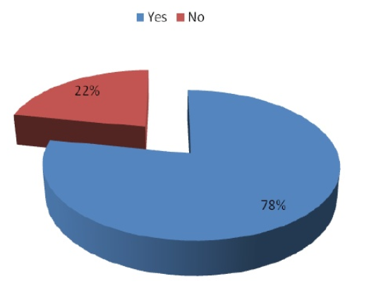
Out of 100 participants 22% say that they are not satisfied with the price of their particular mobile models while 78% say that they satisfied with the amount of money charged on their phones.
5. Between Apple and Samsung which model that offers you with the battery
Response | Percentage
Samsung | 26%
Apple | 74%

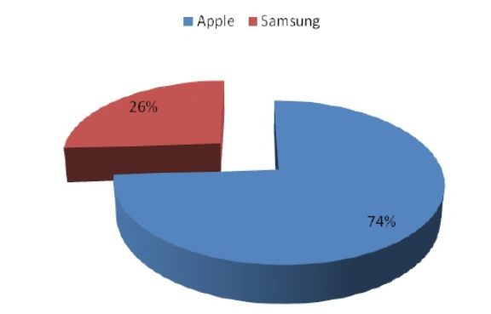
Out of hundred participants 26% says that Samsung Company provide the battery while 74 % says that Apple provides the battery.
6. Which models that offers you the better touch?
Response | Percentage
Samsung | 47%
Apple | 53%

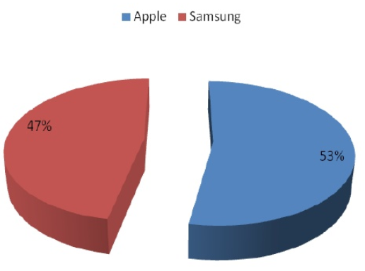
Out of hundred participants 47% says Samsung touch is better while 53% says Apple touch is better.

References
Boulos, M. N. K., Wheeler, S., Tavares, C., & Jones, R. (2011). How smartphones are changing the face of mobile and participatory healthcare: an overview, with example from eCAALYX. Biomedical engineering online, 10(1), 24.

Linden, G., Kraemer, K. L., & Dedrick, J. (2009). Who captures value in a global innovation network?: the case of Apple's iPod. Communications of the ACM, 52(3), 140-144.

West, J., & Mace, M. (2010). Browsing as the killer app: Explaining the rapid success of Apple's iPhone. Telecommunications Policy, 34(5-6), 270-286.

